*Florida International University*

*School of Computing and Information Sciences*

Software Engineering Focus

Feature Document

User Story ID <NVOS-21 Login>

**Name:** Bryan Bastida

**Team Member(s):** Bryan Bastida

Andrew Castillo

**Project:** EnvoScholar

**Product Owner(s)**: Mark Finlayson

**Mentor(s)**: Masoud Sadjadi

**Instructor**: Masoud Sadjadi

**User Story Name: Login**

* Description: As a user, I want to login to my account, so that I can have access to my user specific information.

Acceptance Criteria

* User has accessed website
* User has pressed the Account button
* User is taken to a new page with login credentials
* User fills out out their login credentials then presses the Sign In button

**Use Case**

* Name: Login
* Actor: User and Website
* Preconditions: User has accessed the website

User has pressed the Account button

* Description <Flow of events>:
  + User accesses the Envo Scholar website
  + User presses the Account button
  + User types in e-mail and password
  + User presses Sign In

**Use Case Diagram**

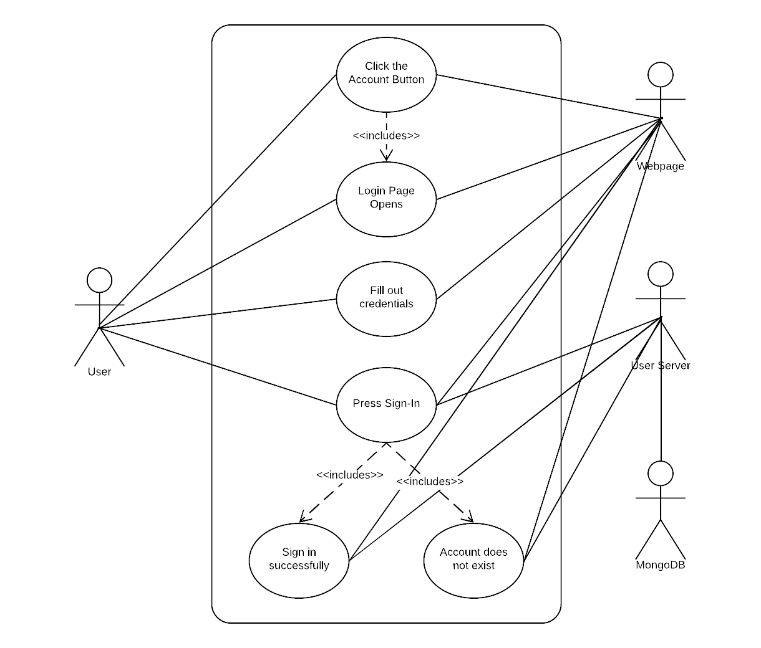

**Sequence Diagram**

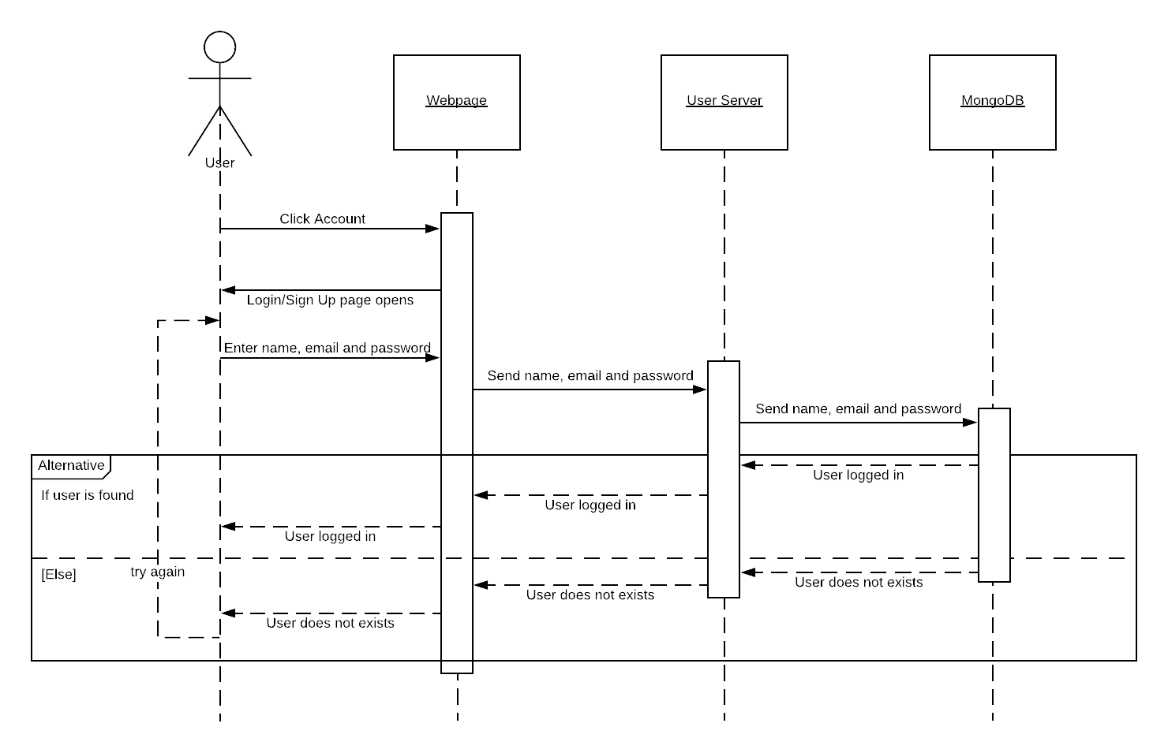

**Class Diagram**

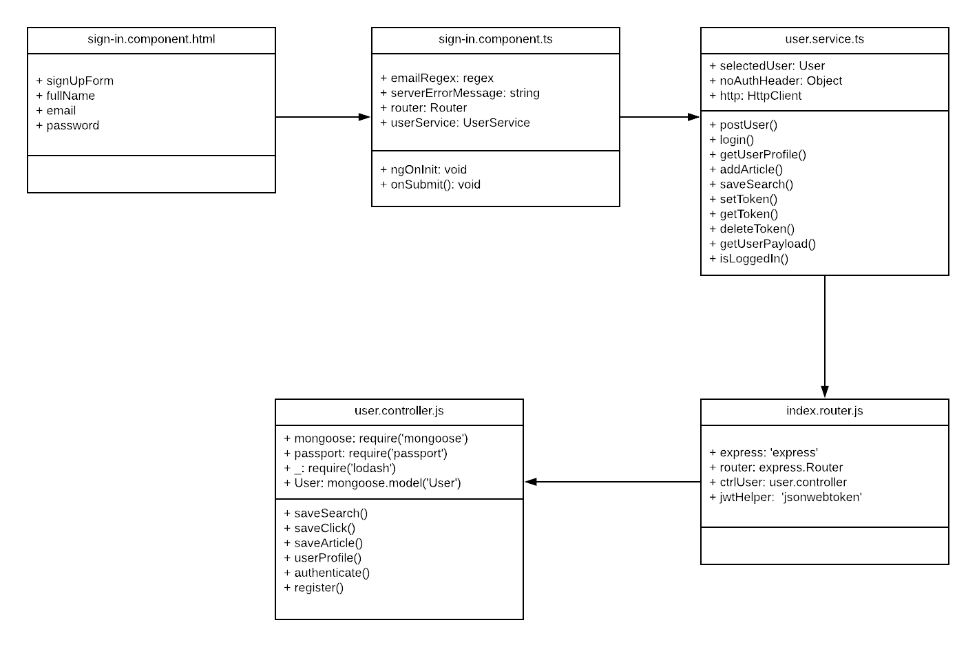

## ****Unit Test****

* Test case ID: NVOS-21-Login
* Description/Summary of Test: User has clicked on the Sign In button. Login page opens. User enters his/her login credentials then clicks login. User is now logged in.
* Pre-condition: User has clicked on the Account button. Login page opens. User enters his/her login credentials then clicks login.
* Expected Results: User is logged in.
* Actual Result: User is logged in.
* Status (Fail/Pass): Pass

**Visual User Guide**

